

**Product-Mix optimization problem**

**SCM 518: Analytical Decision Modeling I**

***Team 22492 – Data Pantheon***

Kiran Pramod Murchite (Contribution - 20%)

Smitha Raju Basavaraju (Contribution - 20%)

Nitish Potedar (Contribution - 20%)

Abhiram Cheruku (Contribution - 20%)

Yijian Zheng (Contribution - 20%)

# Background

AA Ozzy Bakery is a traditional Taiwanese bakery that has been in business for many years; located in Mekong Plaza, Mesa. Established in 2007, AA Ozzy bakery has been the must-go shopping destination for the Asian community and the local residents whenever visiting the neighborhood. The owner is a Taiwanese lady named Joanne. Joanne runs bakeries both in Taiwan and in the United States. The store in Arizona is limited by size and the number of customers but her bakery in Taiwan has a larger scale and greater income. Therefore, she mainly spends her time and energy on business in Taiwan. For AA Ozzy Bakery in Arizona, she has hired a baker as an agent to manage it. Baker ‘Bella’ makes a variety of breads, tarts, loaves and cookies according to her own time and approximate customer needs. The yogurt bread is their signature product amongst the many mouth-watering breads and pastries. The [Hondo cakes](https://www.aaozzy.com/collections/hondo-cakes) are the most popular item of all time.

Joanne wants us to maximize AA Ozzy Bakery's profit with the current situation and it's better to tell her what products should be made every day, rather than let the baker do it intuitively.

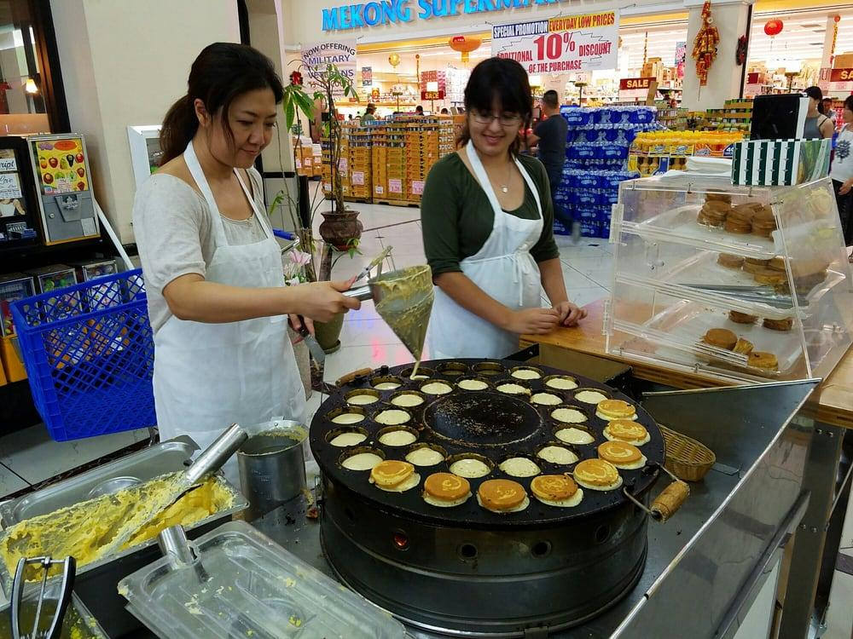

There are many part time workers with only one full-time baker. Salary for the baker is $15/hour and 48 working hours per week and salary for part time workers is $12/hour and 120 hours per week. The AA Ozzy Bakery Online Shop is currently operating on an in-store pick-up basis only. However, they are planning on expanding their services to deliver home soon.

**Requirement:**

1. Bakers have a production baking limit.

|  |  |  |  |  |  |  |  |  |
| --- | --- | --- | --- | --- | --- | --- | --- | --- |
| Bakers have a production limit | | | | | | | | |
| Items | Monday | Tuesday | Wednesday | Thursday | Friday | Saturday | Sunday | Weekly |
| Bread | 10 | 10 | 10 | 10 | 10 | 30 | 15 | 95 |
| Tart | 1 | 1 | 1 | 1 | 1 | 3 | 0 | 8 |
| Loaf | 0 | 0 | 0 | 0 | 3 | 3 | 4 | 10 |
| Cookie | 0 | 0 | 4 | 0 | 0 | 0 | 4 | 8 |

**Table 1: Production limits**

1. Bread baked 2 cycles more than the customer demand can only sell 60%, and the rest will be thrown away because of expiration. So, the max baking time for breads is (2 + customer demand).
2. Joanne estimates the weekly demand for each item as below:

**Table 2: weekly demand specimen**

1. For Meat, Milano cream and Green Onion materials, the bakery needs to ensure freshness of ingredients. These ingredients can only be imported once a week and in order to not waste these ingredients, the imported quantity is fixed. This means that the total number of baking cycles that need these ingredients is constant.

|  |  |
| --- | --- |
| Items | Max Baking Cycles |
| Meat bread | 8 |
| Milano bread | 20 |
| Green Onion bread: | 8 |

**Table 3: Baking time**

1. Since there are most customers on Saturday, Joanne requires that each flavor of bread be made at least once. In addition, bread of the same type cannot be made more than twice a day.
2. To incentivize employee performance, Joanne promises a percentage (10%) of their weekend profit as employee’s bonuses.
3. Since general demand for tarts, loaves and cookies are not high, Joanne prefers to make each flavor of tarts/loaves/cookies at most once per day

**What items should the baker bake weekly to maximize the profit of the bakery?**

**Table 4: item information specimen**

**For the mathematical model, we considered the requirements 1,2,3,4 and established the model below.**

**Model (1):**

**Inputs:**

i -> Index of each item the bakery sells

$P_{i}$-> The price of each item ‘i’ in each baking cycle (unit price* number pieces)

$C_{i}$-> The cost to make each item ‘i’ per baking cycle

$D_{i}$-> Weekly baking cycles demand for item ‘i’

$M_{i}$-> Maximum number of baking cycles for item ‘i’

MB: Baker’s max weekly ability to bake bread in terms of baking cycles

MT: Baker’s max weekly ability to bake tarts in terms of baking cycles

ML: Baker’s max weekly ability to bake loaves in terms of baking cycles

MC: Baker’s max weekly ability to bake cookies in terms of baking cycles

BM: Maximum number of baking cycles for Meat breads

BC: Maximum number of baking cycles for Milano cream breads

BG: Maximum number of baking cycles for Green Onion breads

**Decisions:**

$X_{i}$-> Number of baking cycles a baker should use for each item ‘i’

**Objective:**

$Max Σ \left(D_{i}\left(P_{i}-C_{i}\right)\right)+Σ(\left(X_{i}-D_{i}\right)\left(0.6*P_{i}-C_{i}\right))$

**Constraints:**

1. $X_{i}$ = Integer

$X_{i} ≥ D_{i}$

$X_{i} ≥ 0$

$X_{i}≤$ $M_{i}$

$MB≥Σ_{i\left(Breads\right)}X_{i}$

4. MT $≥Σ_{i\left(Tarts\right)}X_{i}$
5. ML $≥Σ_{i\left(Loafs\right)}X_{i}$
6. MC $≥Σ_{i\left(Cookies\right)}X_{i}$
7. BM $≥Σ_{i\left(BBQ, Spicy BBQ\right)}X_{i}$
8. BC $≥Σ_{i\left(All milano type breads\right)}X_{i}$
9. BG $≥Σ_{i\left(All grean onion type breads\right)}X_{i}$

The results of the model 1 show that the maximum weekly revenue of the bakery is

$5090.224 (before considering the labor cost and fixed cost). In addition, we also know how many times each item should be baked weekly to maximize revenue as shown in the table below:



**Table 5: Weekly baking cycles specimen (Xi)**

**Is it necessary to hire one more baker ?**

If we need to hire one more baker, we just need to change the data of the input MT, ML, MC (baker’s maximum weekly baking ability of items) and then run the model again.

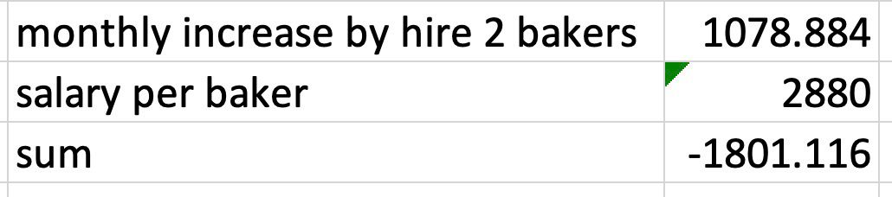

**Table 6: baker cost information**

As the output shows. There will be increase in profit of $1078, but Joanne needs to pay $2880 extra as the salary of the second baker, so hiring one more baker is not feasible.

**Which items should the baker bake daily in order to minimize the bonus?**

We split the breads and other items and solved them using two separate models

**Model for breads (2):**

**Inputs:**

i -> Index of each bread item the bakery sells

j -> index for each day in a week [j=1 for Saturday and j=2 for Sunday]

${BT}_{i}$-> $X_{i}$ (as per the first model) baking cycles for each bread item ‘i’

${DBB}_{j}$-> baker’s daily ability to make breads in terms of baking cycles

**Decisions:**

$X_{ij}$-> Number of baking cycles of bread ‘i’ needed on day ‘j’

**Objective:**

*Min $\sum_{i}{\sum_{j}{{(X}_{ij}})*(P_{i}-C_{i})}$*

**Constraints:**

$\sum_{i}{\sum_{j}{{(X}_{ij}})}≥$ ${BT}_{i}$

${DBB}_{j}$ $≥$ $\sum_{i}{\sum_{j}{{(X}_{ij}})}$

3. $X_{i1}=1$ (Note: bread ‘Bolo’ had to be excluded because it was causing a constraint conflict)

$X_{ij}=Integer$

$X_{ij}$ $≥0$

$X_{ij}≤2$

**Note –**

* We are minimizing the total revenue of Saturday and Sunday to minimize the money paid out for bonuses.
* In order to minimize the bonus, we need to assign the items which generate less profit to weekends and assign the items which generate high profit to week days.
* For example, if we consider the bread A generating 50 dollars profit and bread B generating 80 dollars profit, making type B bread on weekends compels us to pay out 8 dollars bonus to the employees. So, we assign more number bread B to weekends rather than A since only 5 dollars need to be paid out.

**Model** **for tarts, cookies and loaves (3):**

**Inputs:**

i -> index of tarts, loaves, and cookies

j -> index for each day in a week

${DBT}_{j}$-> Baker’s ability to make tarts each day ‘j’ in terms of baking cycles

${DBL}_{j}$-> Baker’s ability to make loaves each day ‘j’ in terms of baking cycles

${DBC}_{j}$-> Baker’s ability to make cookies each day ‘j’ in terms of baking cycles

${BT}_{i}$-> $X_{i}$ (as per the first model) baking cycles for each item ‘i’ (tarts, loaves, and cookies)

**Decisions:**

$X_{ij}$-> Number of baking cycles of item ‘i’ (tarts, loaves, and cookies) needed on day ‘j’

**Objective:**

*Min $\sum_{i}{\sum_{j}{{(X}_{ij}})*(P_{i}-C_{i})}$*

**Constraints:**

$X_{ij}$ $≥$ ${BT}_{i}$

2. ${DBT}_{j}$ $≥$ $\sum_{i}{\sum_{j}{{(X}_{ij}})}$ [where i ∈ (1,5) - tarts]
3. ${DBL}_{j}$ $≥$ $\sum_{i}{\sum_{j}{{(X}_{ij}})}$ [where i ∈ (6,11) - loaves]
4. ${DBC}_{j}$ $≥$ $\sum_{i}{\sum_{j}{{(X}_{ij}})}$ [where i ∈ (12,16) - cookies]
5. $X_{ij}$ = Binary [since the number of tarts, loaves and cookies baked can be 0 or 1 as per the demand]

Regarding the second and third models, we added some inputs based on requirements 7, 8. We encountered some feasibility problems of model building when building model 2 and 3. After further checking the model building report, we found two over-constrained parts:

1. Bolo items should not be included to maximize the profit since it was causing a conflict in constraints, but Joanne asked to make each flavor of bread at least once at Saturday. We suggested just cutting this production because the bakery loses profit each time it bakes Bolo bread.

2. Coconut macaron should be made 3 times weekly, but Joanne asked to make each flavor of cookies at most once per day, and the baker only has 2 days to make cookies every week. So, we suggested adding one more day to make cookies.

The figure below is our final result. We recommended that the bakery bake daily items according to the following results to maximize the monthly profit. At the same time, Joanne can also pay employees a minimum weekend bonus.

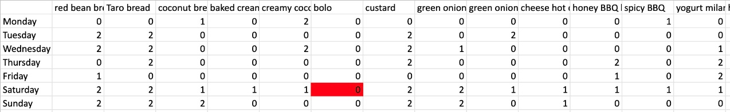

**Table 7: daily baking suggestion**

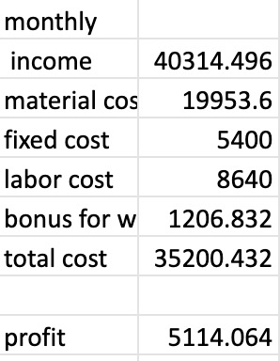

**Table 8: monthly financial report**

**Learnings:**

We learnt how to translate a real business problem into a mathematical model and solve it using optimization tools like linear programming. Linear programming methods are often helpful at solving problems related to production. A company that produces multiple types of products can use linear programming methods to calculate how much of each product to produce to maximize its profits or reduce cost.

**Conclusion:**

We established close communication with project customers, because the data given by customers may need to be updated and customers may change some specific requirements or goals according to the phased result of the project. We successfully met all of Joanne’s requirements.

We shared the conclusions of the model with Joanne, the bakery owner, and she accepted the suggestion to make cookies twice on Monday and Wednesday rather than making 4 cycles on just Wednesday and the baker agreed. However, Joanne hesitated over the proposal to remove Bolo bread from shelves because she doesn't know the bundling status of Bolo bread - if there is no Bolo bread, the sales of other bread may also be affected (like the beer and diaper example). She said that she would temporarily remove Bolo bread for a month and decide whether to permanently remove Bolo bread based on customer feedback.

**Suggestions on how to make the project better:**

The problem had a lot of input variables which is why we had to split the items across two models. This can be better solved using Python and Gurobi Optimization since it can handle any number of variables.